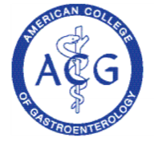

**World Congress of Gastroenterology @ ACG2017**

**October 13 – 18, 2017, Orange County Convention Center, Orlando, Florida**

**worldcongressacg2017.org**

**AMERICAN COLLEGE OF GASTROENTEROLOGY**

6400 Goldsboro Road, Suite 200, Bethesda, Maryland 20817-5842

P: 301-263-9000; F: 301-263-9025; Website: gi.org

**BOARD OF TRUSTEES**

**2016– 2017**

President

CAROL A. BURKE, M.D., FACG

Cleveland, Ohio

216-444-6864

President-Elect

IRVING M. PIKE, M.D., FACG

Walnut Creek, California

925-941-4250

Vice President

SUNANDA V. KANE, M.D., MSPH, FACG

Rochester, Minnesota

507-284-0959

Secretary

DAVID A. GREENWALD, M.D., FACG

New York, New York

212-241-7535

Treasurer

MARK B. POCHAPIN, M.D., FACG

New York, New York

646-501-6760

Immediate Past President

KENNETH r. DEVAULT, M.D., FACG

Jacksonville, Florida

904-953-2254

Past President

Stephen B. Hanauer, M.D., FACG

Chicago, Illinois

312-695-4929

Director, ACG Institute

NICHOLAS J. SHAHEEN, M.D., MPH, FACG

Chapel Hill, North Carolina

919-966-7047

Co-Editors, *The American Journal   
of Gastroenterology*

Brian E. Lacy, M.D., Ph.D., FACG

Lebanon, New Hampshire

603-650-5215

Brennan M. R. Spiegel, M.D., MSHS, FACG

Los Angeles, California

310-423-6467

Chair, Board of Governors

Costas H. Kefalas, m.d., MMM, facg

Akron, Ohio

330-869-0124

Vice Chair, Board of Governors

DOUGLAS G. ADLER, m.d., facg

Salt Lake City, Utah

801-581-7878

Trustee for Administrative Affairs

DELBERT L. CHUMLEY, M.D., FACG

San Antonio, Texas

210-614-1234

**TRUSTEES**

WILLIAM D. CHEY, M.D., FACG

Ann Arbor, Michigan

734-936-4775

Lauren B. Gerson, M.D., MSc, FACG

San Francisco, California

415-674-5200

Caroll D. Koscheski, M.D., FACG  
Hickory, North Carolina  
828-328-3300

PAUL Y. KWO, M.D., FACG

Palo Alto, California

650-498-6080

JONATHAN A. LEIGHTON, M.D., FACG

Scottsdale, Arizona

480-301-6990

Daniel J. Pambianco, M.D., FACG

Charlottesville, Virginia

434-817-8484

DAVID T. RUBIN, M.D., FACG

Chicago, Illinois

773-702-2950

JOHN R. SALTZMAN, M.D., FACG  
Boston, Massachusetts  
617-525-8763

SAMIR A. SHAH, M.D., FACG

Providence, Rhode Island

401-274-4800

SCOTT M. TENNER, M.D., MPH, JD, FACG

Brooklyn, New York

718-368-2960

**Executive Director**

BRADLEY C. STILLMAN

January 11, 2017

Thelma King Thiel, Chair

Liver Health Initiative

504 Blick Drive

Silver Spring, MD 20904

Dear Ms. Thiel:

The American College of Gastroenterology supports the work of the Liver Health Initiative to ensure that individuals understand the impact that their choices and behaviors can have on the liver and its hundreds of life sustaining functions. ACG applauds your efforts to ensure that liver health education is included in the final report of the National Academies of Sciences-Engineering-Medicine *National Strategy for the Elimination of Viral Hepatitis B and C in the United States*.

|  |  |
| --- | --- |
|  |  |

As an organization of gastroenterology and hepatology specialists who are committed to digestive health including the health and integrity of the liver, the College recognizes the importance of education that empowers young people to assess their own risk behaviors, seek testing for potential viral infection, and avoid future activities that could potentially harm the liver.

Based the research studies you shared, as well as extensive evaluations of similar liver health education programs, ACG supports inclusion of liver health education as a critical component of liver disease prevention efforts by the National Academies in their final report to the nation.

Very Truly Yours,

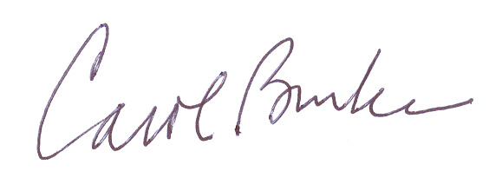

Carol A. Burke, MD, FACG

ACG President

cc: Bradley C. Stillman, Esq. ACG Executive Director [bstillman@gi.org](mailto:bstillman@gi.org)

Brian L. Strom, MD, MPH, [chancellor@rbhs.rutgers.edu](mailto:chancellor@rbhs.rutgers.edu)

Gillian Buckley, [gbuckley@nas.edu](mailto:gbuckley@nas.edu)